1. For this challenge, forget how to add two numbers together. The best explanation on what to do for this function is this meme:

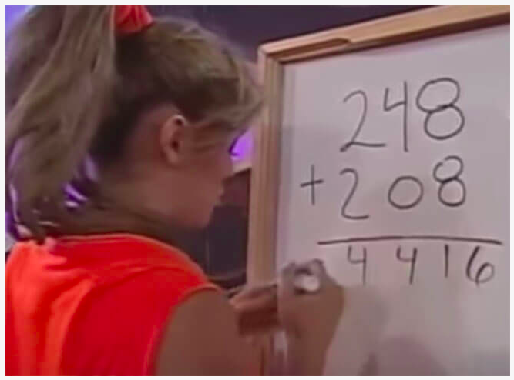

**Examples**

meme_sum(26, 39) ➞ 515

# 2+3 = 5, 6+9 = 15

# 26 + 39 = 515

meme_sum(122, 81) ➞ 1103

# 1+0 = 1, 2+8 = 10, 2+1 = 3

# 122 + 81 = 1103

meme_sum(1222, 30277) ➞ 31499

def meme_sum(num,num2):

a,b = str(num),str(num2)

c=""

while len(a) != len(b):

if len(a) < len(b):

a ='0'+a

else:

b='0'+b

for i in range(len(a)):

c+=str(int(a[i])+int(b[i]))

print(f"meme_sum{num,num2} ---> {c}")

meme_sum(12, 810)

2. Given an integer, create a function that returns the next prime. If the number is prime, return the number itself.

**Examples**

next_prime(12) ➞ 13

next_prime(24) ➞ 29

next_prime(11) ➞ 11

# 11 is a prime, so we return the number itself.

def isPrime(n):

if n==1:

return True

else:

for i in range(2,int(n/2)+1):

if n%i==0:

return False

return True

def next_prime(x):

if isPrime(x):

return x

else:

while(isPrime(x)!=True):

x=x+1

return x

print(next_prime(10) )

3. If a person traveled up a hill for 18mins at 20mph and then traveled back down the same path at 60mph then their average speed traveled was 30mph.

Write a function that returns the average speed traveled given an uphill time, uphill rate and a downhill rate. Uphill time is given in minutes. Return the rate as an integer (mph). No rounding is necessary.

**Examples**

ave_spd(18, 20, 60) ➞ 30

ave_spd(30, 10, 30) ➞ 15

ave_spd(30, 8, 24) ➞ 12

def ave_spd(time1,speed1,speed2):

uptime = time1/60

distance = speed1 * uptime

totaldistance = distance*2

timedown = distance/speed2

totaltime = uptime + timedown

totalspeed = totaldistance/totaltime

print(totalspeed)

ave_spd(18, 20, 60)

4. The Kempner Function, applied to a composite number, permits to find the smallest integer greater than zero whose factorial is exactly divided by the number.

kempner(6) ➞ 3

1! = 1 % 6 > 0

2! = 2 % 6 > 0

3! = 6 % 6 === 0

kempner(10) ➞ 5

1! = 1 % 10 > 0

2! = 2 % 10 > 0

3! = 6 % 10 > 0

4! = 24 % 10 > 0

5! = 120 % 10 === 0

A Kempner Function applied to a prime will always return the prime itself.

kempner(2) ➞ 2

kempner(5) ➞ 5

Given an integer n, implement a Kempner Function.

**Examples**

kempner(6) ➞ 3

kempner(10) ➞ 5

kempner(2) ➞ 2

def kempner(in_num):

def factorial(in_num):

if in_num == 1:

return 1

else:

return in_num * factorial(in_num-1)

for ele in range(1,in_num+1):

if factorial(ele)%in_num == 0:

output = ele

break

print(f'kempner({in_num}) --->z {output}')

kempner(10)

5. You work in a factory, and your job is to take items from a conveyor belt and pack them into boxes. Each box can hold a maximum of 10 kgs. Given a list containing the weight (in kg) of each item, how many boxes would you need to pack all of the items?

**Example**

boxes([2, 1, 2, 5, 4, 3, 6, 1, 1, 9, 3, 2]) ➞ 5

# Box 1 = [2, 1, 2, 5] (10kg)

# Box 2 = [4, 3] (7kg)

# Box 3 = [6, 1, 1] (8kg)

# Box 4 = [9] (9kg)

# Box 5 = [3, 2] (5kg)

def boxes(in_list):

in_list_clone = in_list.copy()

output = []

temp_box = []

while True:

if len(in_list) != 0:

if sum(temp_box) <= 10:

temp_box.append(in_list.pop(0))

else:

in_list.insert(0,temp_box.pop())

output.append(temp_box)

temp_box = []

else:

output.append(temp_box)

temp_box = []

break

print(f'boxes({in_list_clone}) --> {output} --> {len(output)}')

boxes([2, 1, 2, 5, 4, 3, 6, 1, 1, 9, 3, 2])